Week 6 Practical

- Router
- Server > Services>DHCP
- 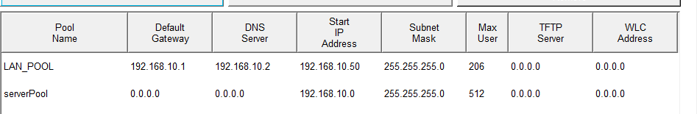

Section 2
- A record
- DNS Server

c.
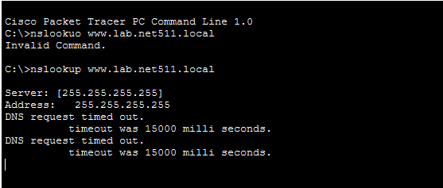

Section 3

- 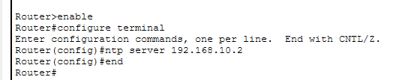

- HTTP is insecure, making data vulnerable to theft (like a postcard). HTTPS is encrypted, protecting sensitive information like passwords and credit card numbers.

Section 5: SSH: Secure Shell

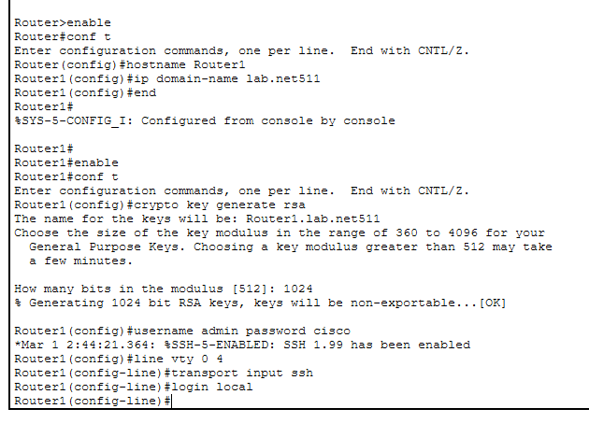

b. TCP port 22

c.